**Programming the PST Bootlader:**

Items Needed

* MPLABX
* Bootloader code
* USB Cable
* PST

Instructions

* Open MPLABX
* Select project UBW32_HIDBOOT_MX460 and right click it. Select “Set as Main Project”

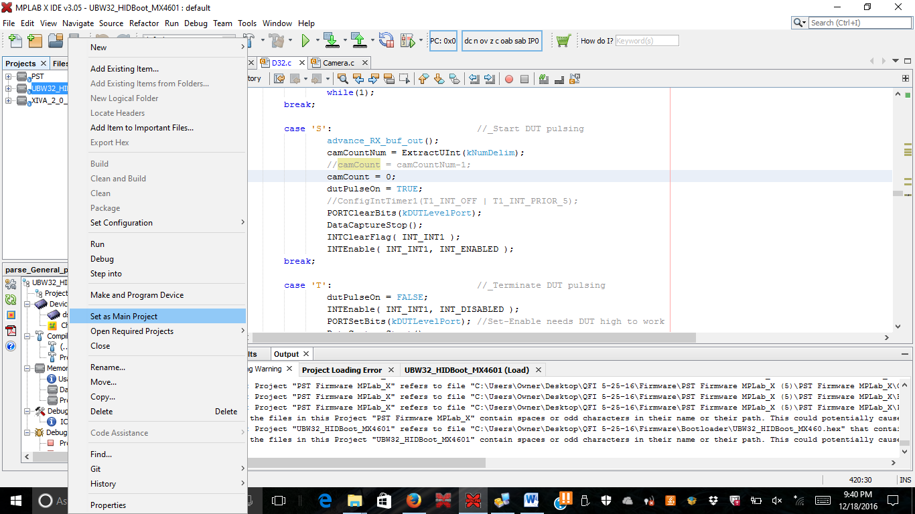

* Right click the project and click “Run”. This will load the bootloader.